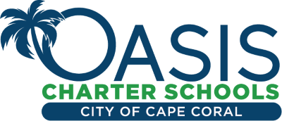
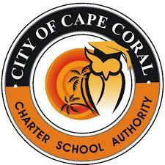

GB MEETING CANCELED – JANUARY 16, 2024

Charter School Authority Governing Board Meeting
Scheduled for Tuesday, January 16, 2024, has been CANCELED.
Due to inclement weather conditions and expected heavy rains,
tonight's meeting has been canceled.

The CSA Governing Board reconvenes
at the Next Regular Meeting on
Tuesday, February 13, 2024, at 5:30p.m. at Oasis Elementary South - Cafeteria, 3415 Oasis Blvd., Cape Coral, FL 33914

Thank you for your patience and understanding. Stay Safe!

