November 2016
Cape Coral Charter Authority NEWSLETTER
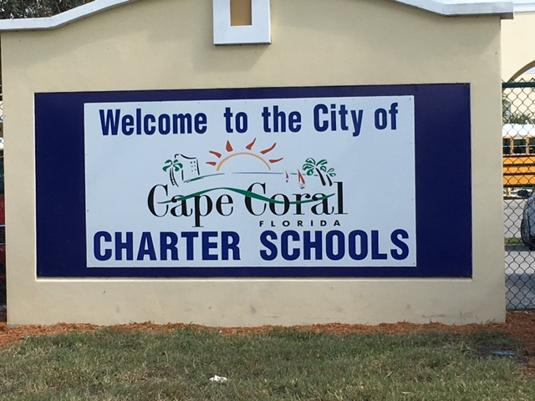

Charter Events

November 1 - November 3
Spirit Night, Chick-Fil-A
Mention one of our schools for credit!

November 5
4-8pm: Fall Festival, OES Campus

November 8
9am: Governing Board Meeting, OMS Cafeteria

November 15
8am: Foundation Meeting, OHS Cafeteria

November 19
4-9pm: Fall Festival, CME Campus

December 16
4:30-9pm: Winter Music Festival, OES Airnasium

For a complete listing of events at all 4 schools, visit:
http://www.capecharterschools.org/events

www.capecharterschools.org
Dear Parent,
We are constantly trying to give you information in a concise and easy format. We know that principals and teachers are communicating frequently, but we hope this newsletter provides a bit more insight into the Cape Coral Charter Authority.

Did you know that that recently updated all 4 school websites as well as the Foundation website and the Charter Authority website so they have a consistent look and information?

Did you know we have a YouTube channel that broadcasts our Governing Board meetings?

Our websites are a wealth of information and we hope you are finding them helpful.

Nelson Stephenson, Superintendent

Exciting News

Communications
This year we rolled out Schoology in the Middle and High School. An informational meeting was held at the Middle School for any parents needing tutorial on this new communication tool. We are getting positive feedback on the tool and hope parents at those schools sign up for it soon if you have not done so already.

We have also been working for months on a app to replace K-12. We are not done but wanted you to know that it is in the works. This will allow you to customize how much or how little information is sent to you. Be on the lookout for this to be rolled out in the next few months.

Grants Writer
In order for our school to take advantage of the many grants available, we are in search of volunteers willing to do some grant writing. Anyone who might be interested should contact Nelson Stephenson at nelson.stephenson@capecharterschools.org

Foundation Update

Who We Are
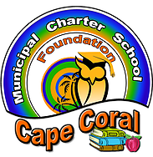

Important Dates

December 1
Lighthouse Nominations Due

January 12
Lighthouse Applications Due

January 30
Lighthouse Finalists Announced

March 26

Charter Authority Rally, German American Club

FREE & open to the public!

March 31

Lighthouse Winner Announced

May 5

Lighthouse Award Dinner, Yacht Club
Teachers, Family, Friends & Parents are invited to attend!

The Foundation is the fundraising arm of the Cape Coral Charter Authority. We are made up of parent volunteers who want to help the school. We invite anyone to join us at our meetings on the 2nd Tuesday of each month in the High School cafeteria.

What We Do
Our main initiatives are:
- Charter Authority Rally
- Lighthouse Awards
- Mini-Grants for Teachers
- Scholarships for Students
The Charter Authority Rally is our largest system-wide fundraiser that benefits all four schools and the Foundation. The event will be held on Sunday, March 26th from 12-6pm at the German American Club. The event will feature 4 Time Grammy Nominated Recording artist Joe Nichols, Professional and Local Entertainment, Car Show, Scavenger Hunt, Rides, Games, Food, Beer Stations, Chinese Auction and City of Cape Coral Specialty Vehicles. We are looking for sponsors, donations and volunteers. For more information, visit www.charterauthorityrally.org
The Lighthouse Award Recognition Program is administered by the Cape Coral Charter School Foundation and overseen by the Lighthouse Award Committee, comprised of members of the Charter School Foundation. This program is designed to honor the most deserving teachers within our Charter School System. Nominations can be done online at www.capecharterfoundation.org

Community Partnerships
We have established some partnerships that provide money to the foundation with no additional cost to you!

AMAZONSMILE.com: If you shop on Amazon, be sure selection amazonsmile and designate the “Charter Authority Foundation” as your recipient. A portion of money will come to us just for that simple change! http://smile.amazon.com/ch/38- 3765726

PREMIER AUTO: They give back 5% of any repair done to our four schools. Be sure to refer your family and friends them and have them mention one of our schools. www.premierautoofswfl.com

ACHIEVA CREDIT UNION: Open a new account or mortgage with Achieva and the Foundation will receive a donation. This is a great opportunity to teach your child about saving! www.achievacu.com

Charter Authority Updates

Budget News

School Updates

Christa McAuliffe
Completed their 3rd annual Booster-A-Thon Fun Run raising thousands of dollars for technology.

Students are in rehearsals for Mulan Jr to be held February 17 -18 at Ida Baker HS.

Oasis Elementary
Implemented a new program to help 4th graders achieve better reading fluency.

Students are in rehearsals for Annie Jr. to be held February 22-24 at Ida Baker HS.

Oasis Middle

Students are in rehearsals for Legally Blonde Jr to be held February 15-17 at Mariner HS.

Oasis High
A Parent Teacher Student Organization (PTSO) has been created to help improve communication & involvement at the school. New members are welcome!

Thank you to the Class of 2016 for our new sign!

As you know, charter schools do not receive the same funding as district schools.

Here is the issue: A tax of 1.5 mills is levied on all Florida residents for the purposes of capital expenses for public schools. Capital outlay monies are typically used to pay debt service on buildings, facilities maintenance, and new construction. As our successful system is growing we are facing a need to both increase our facilities student capacity and to provide on-going maintenance of our current facilities.

Presently, local school districts have the discretion to share capital money with charter schools (F.S. 1011.71). Keeping in mind that all Florida residents pay this tax and that the local school district has decided to not share these monies with our system means that the monies paid by parents does not follow their children. We believe that funds our parents pay should follow their children.

Read the complete article from the News-Press at
http://www.news-press.com/story/opinion/2015/04/11/share-property-tax-money-achieving-charter-schools/25610929/

How You Can Help
We are using www.DonorsChoose.Org as a vehicle to raise money for technology and other needs within all four schools. Many of the campaigns can get double funding due to grants they are associated with so we hope you or your company can donate any amount. Search for open campaigns under “Oasis” and “33914”

