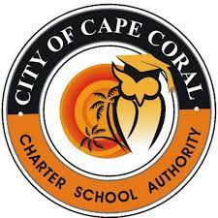

GOVERNING BOARD MEETING – MAY 10, 2022 AT 5:30P.M.
CSA BUDGET WORKSHOP #1
WILL IMMEDIATELY FOLLOW THE REGULAR MEETING

The Next Regular Meeting of the City of Cape Coral Charter School Authority Governing Board will be on Tuesday, May 10, 202, at 5:30 p.m., in City of Cape Coral Council Chambers, 1015 Cultural Park Blvd., Cape Coral, FL 33990
The City of Cape Coral Charter School Authority BUDGET WORKSHOP #1 will also be held on Tuesday, May 10, 2022, at 6:00 p.m., or as soon thereafter as may be heard in the City of Cape Coral Council Chambers.

