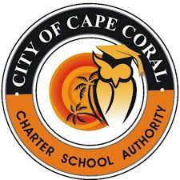
CITY OF CAPE CORAL CHARTER SCHOOL AUTHORITY
GOVERNING BOARD REGULAR MEETINGS 2022-23
All City of Cape Coral Charter School Authority Governing Board Regular Meetings are held at 5:30P.M., in Cape Coral City Council Chambers, at 1015 Cultural Park, Blvd., Cape Coral, FL 33990, unless otherwise notified.

SY 2022-23
January 18, 2022
February 8, 2022
March 8, 2022
April 12, 2022
May 10, 2022
June 14, 2022
August 16, 2022
September 13, 2022
October 11, 2022
November 8, 2022
December 13, 2022
January 17, 2023

